***NAME – KHUSHI PANWAR, khushipanwar26@gmail.com***

***ROLL NO – 33***

***C++ PRACTICAL ASSIGNMENT – 23 DEC 2021***

1. **Write a program that displays all the prime numbers from a given range of numbers :**

#include<iostream>

#include <iomanip>

using namespace std;

int main(){

int num;

cout<<setw(40)<<"__ DISPLAY THE SET OF PRIME NUMBERS __\n"<<endl;

cout<<"This program prints all the prime numbers from a given range"<<endl;

cout<<"Enter the end value of the range: ";

cin>>num;

cout<<"\nAll the prime numbers between 1 and "<<num<<" are as follows : \n"<<endl;

for (int i=2; i<=num;i++){

int flag=0;

for (int k=2; k<i; k++){

if (i%k==0) flag=1; }

if (flag==0){

cout<<i<<endl;

}

}

return 0; }

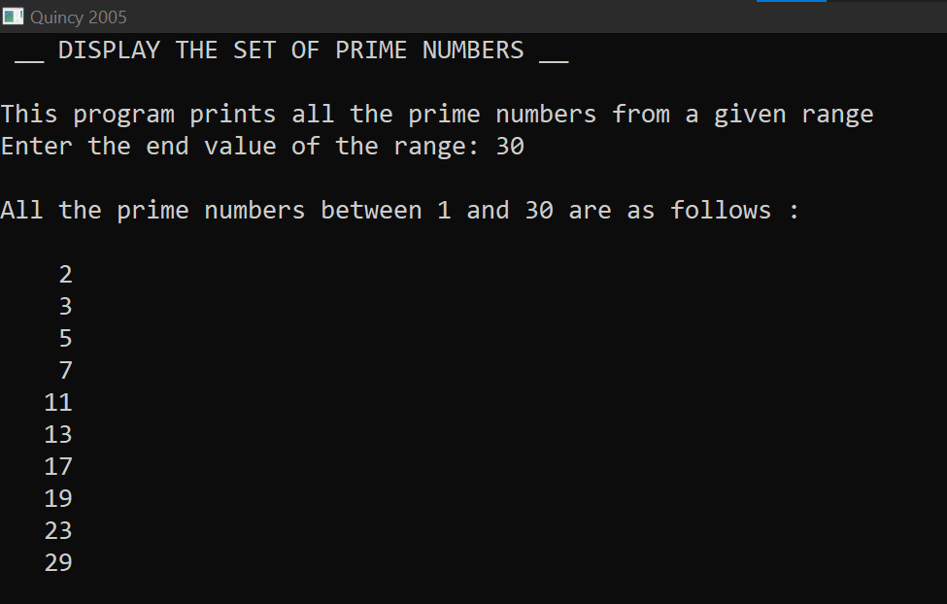

1. **Write a program that only displays the prime numbers out of the list of number entered by the user:**

#include<iostream>

#include<iomanip>

using namespace std;

int main(){

cout<<setw(40)<<"\n __* DISPLAY THE PRIME NUMBERS: C++ PROGRAM *__"<<endl;

int i,n,x,max;

cout<<"\nHow many numbers you want to enter? ";

cin>>n;

cout<<endl;

i=1;

while (i<=n){

cout<<"Enter the number : ";

cin>>x;

int k=2;

int flag=0;

while(k<x){

if (x%k==0) flag=1;

k++;

}

if (flag!=1) cout<<"\t-> Prime number entered: "<<x<<endl;

else cout<<endl;

i++;

}

return 0;

}

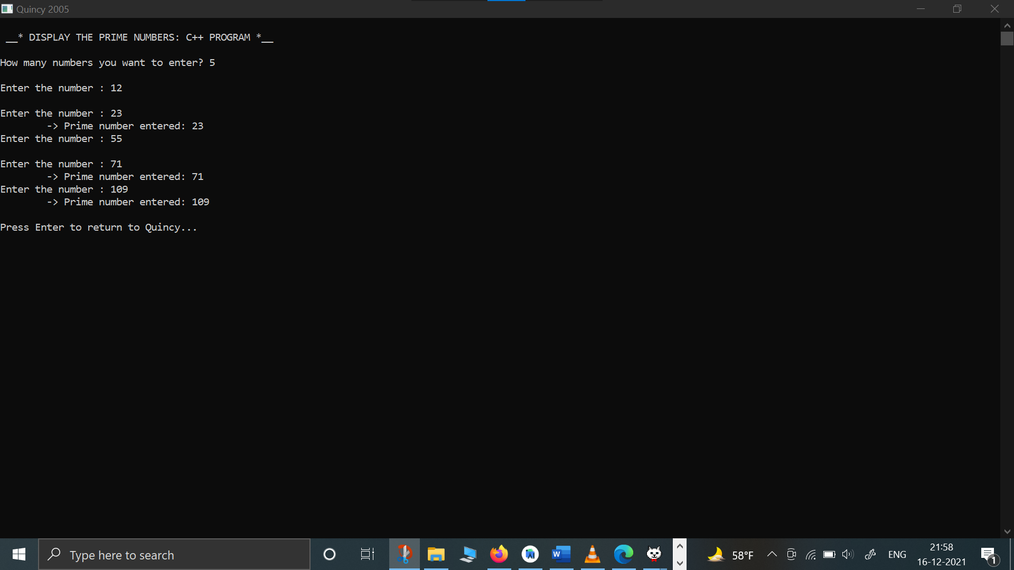

1. **WAP that prints the following pattern :**

**\***

**\* \***

**\* * \***

**\* * * \***

**\* * * * \***

#include<iostream>

#include <iomanip>

using namespace std;

int main(){

cout<<setw(40)<<"__ PYRAMID USING for LOOPS __\n"<<endl;

for (int i =0; i<=5; i++) {

for (int j=1; j<=i;j++){

cout<<" * " ;

}

cout<<endl;

}

return 0;

}

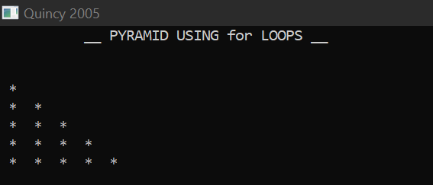

1. **WAP that prints the following pattern :**

**A**

**B B**

**C C C**

**D D D D**

**E E E E E**

#include<iostream>

#include <iomanip>

using namespace std;

int main(){

cout<<setw(50)<<"__ PYRAMID OF ALPHABETS USING LOOPS __\n"<<endl;

char ch='A';

for (int i =0; i<=5; i++) {

for (int j=0; j<=i;j++){

cout<<ch<<" ";

}

ch++;

cout<<endl;

}

return 0;

}

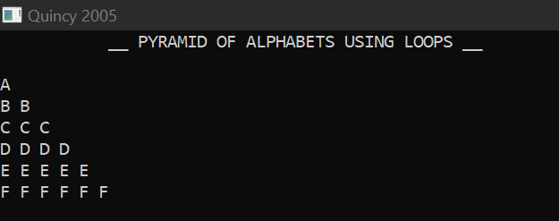

1. **WAP that prints the following pattern :**

**1**

**2 2**

**3 3 3**

**4 4 4 4**

**5 5 5 5 5**

#include<iostream>

#include <iomanip>

using namespace std;

int main(){

cout<<setw(50)<<"__ PYRAMID OF NUMBER USING LOOPS __\n"<<endl;

for (int i =0; i<=5; i++) {

for (int j=1; j<=i;j++){

cout<<j<<" ";

}

cout<<endl;

}

return 0;

}

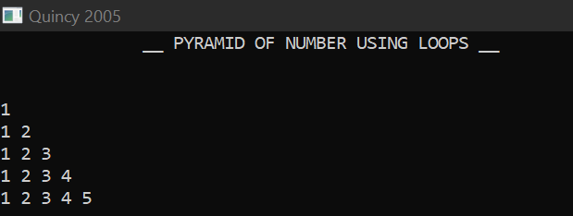

1. **WAP that prints the following pattern :**

**1**

**2 3 2**

**3 4 5 4 3**

**4 5 6 7 6 5 4**

**5 6 7 8 9 8 7 6 5**

#include<iostream>

#include <iomanip>

using namespace std;

int main(){

cout<<setw(50)<<"__ DYNAMIC PYRAMID OF NUMBER USING LOOPS __\n"<<endl;

int j=1;

int i;

int max=10;

for (i =1; i<=5; i++) {

cout<<setw(max);

for (int k=i; k<=j;k++)

cout<<k;

for (int u=j-1; u>=i; u--)

cout<<u;

cout<<endl;

j=j+2;

max=max-1;

}

return 0;

}

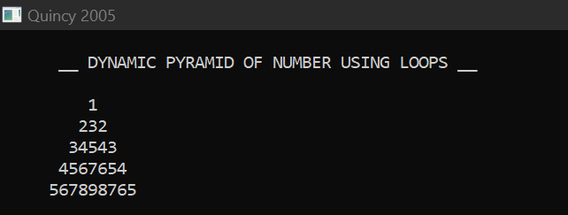

1. **WAP that prints the full pyramid :**

**\***

**\* * \***

**\* * * * \***

**\* * * * * * \***

**\* * * * * * * * \***

#include<iostream>

#include <iomanip>

using namespace std;

int main(){

cout<<setw(40)<<"__ FULL HALF PYRAMID __\n"<<endl;

int max=20;

for (int i=0; i<5; i++){

cout<<setw(max);

for (int k=1;k<=i+1;k++) //left side stars

cout<<" * ";

for (int j=1; j<=i; j++) //right side stars

cout<<" * " ;

cout<<endl;

max=max-3;

}

return 0;

}

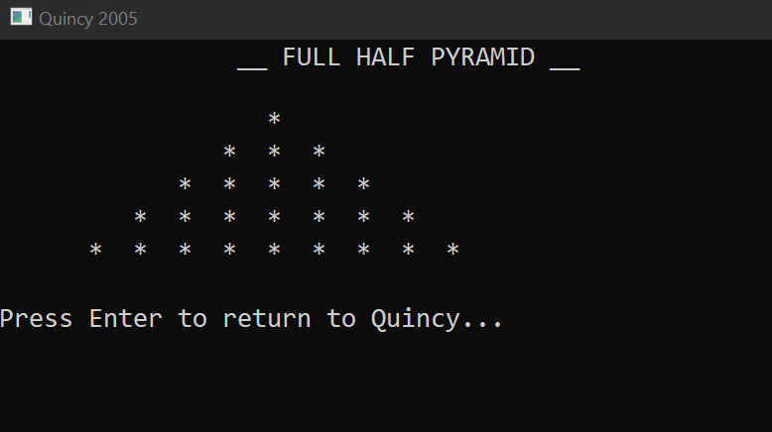

1. **WAP that prints the following inverted half pyramid :**

**\* * * * \***

**\* * * \***

**\* * \***

**\* \***

**\***

#include<iostream>

#include <iomanip>

using namespace std;

int main(){

cout<<setw(40)<<"__ INVERTED HALF PYRAMID __\n"<<endl;

for (int i=5; i>=0; i--) {

for (int j=0; j<=i;j++){

cout<<" * " ;

}

cout<<endl;

}

return 0;

}

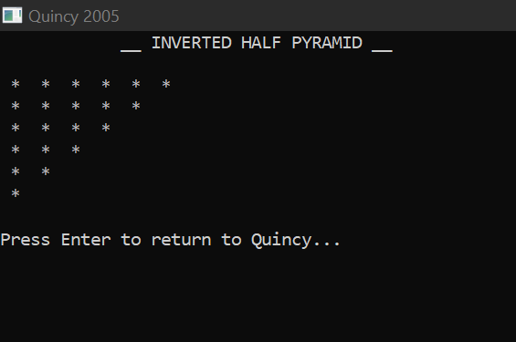

1. **WAP that prints the following inverted half pyramid :**

**1 2 3 4 5**

**1 2 3 4**

**1 2 3**

**1 2**

**1**

#include<iostream>

#include <iomanip>

using namespace std;

int main(){

cout<<setw(40)<<"__ INVERTED HALF PYRAMID USING NUMBERS __\n"<<endl;

for (int i=5; i>=0; i--) {

for (int j=1; j<=i;j++){

cout<<j<<" " ;

}

cout<<endl;

}

return 0;

}

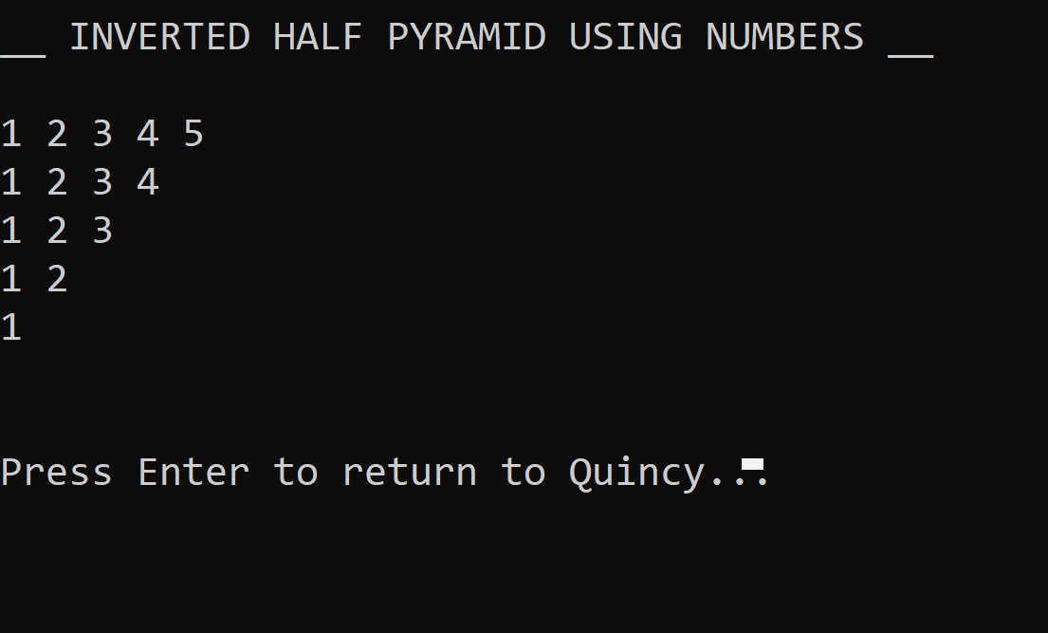

1. **WAP that prints the following pattern but the number of rows depend on user input :**

**\***

**\* \***

**\* * \***

**\* * * \***

**\* * * * \***

#include<iostream>

#include <iomanip>

using namespace std;

int main(){

cout<<setw(50)<<"__ PYRAMID of * USING LOOPS __\n"<<endl;

int row;

cout<<"Enter the number of rows you want : ";

cin>>row;

for (int i =0; i<=row; i++) {

for (int j=1; j<=i;j++){

cout<<" * ";

}

cout<<endl;

}

return 0;

}

